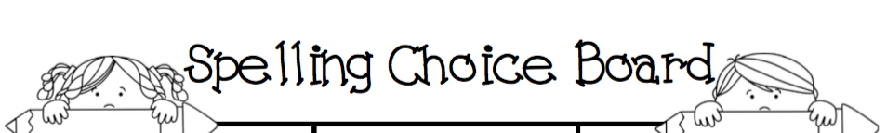
Year 3 and 4 Term One Weeks 3 to 7

- Cheer your words  Pretend you are a cheerleader and call out your words! | Pyramid Words  Write all of your spelling words one letter at a time in the form of a pyramid. | Write it Right!  Write all of your spelling words five times each in your best handwriting. | Hide the Words  Draw a picture of your favorite place and illustrate it with at least 7 colors. Hide your words in the picture.
Make a Collage  Create a collage of all your spelling words using art supplies or magazines. | Timer  Set a timer for three minutes. See how many times you can write your words before the timer goes off. | - Sentences  - Write a sentence for each spelling word. | Trace Around  Print your spelling words neatly. Take a coloured pen and draw an outline around the word, closely following the shapes of the letters.
Snap and Spell  Click your fingers on each letter and clap when you say the word at the end. | - Repetition  - Write your words 3 times each | Words-in-words  Write your word and then write at least 2 words made from each. | - Scramble  Have a parent scramble your spelling words. You can unscramble them.
Colorful Words  Use two different color pens to write your spelling words. Use one color to write the consonants and the other for the vowels. | - Handwriting  Write each word 3 times in your best handwriting. | - Spelling Train  Write out all of your spelling words one after the other without leaving spaces. Write each word in a different colour. | Sentences  Write a sentence for each spelling word.

